https://eu.industrial.panasonic.com/products/capacitors/film-capacitors/ac-motor-use

1. High Safety & Long Life by Built-In Fuse Function
Patterned Metallization with Fuse Function & Safety Mechanism
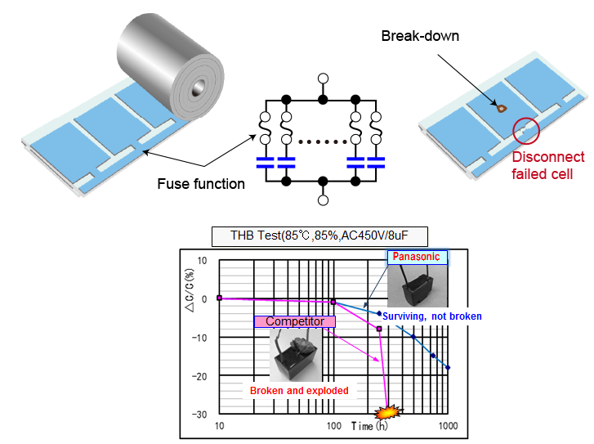

https://eu.industrial.panasonic.com/products/capacitors/film-capacitors/automotive-industrial-and-infrastructure-use#safetystandard

1. High Safety & Long Life by Built-In Fuse Function
Patterned Metallization with Fuse Function & Safety Mechanism
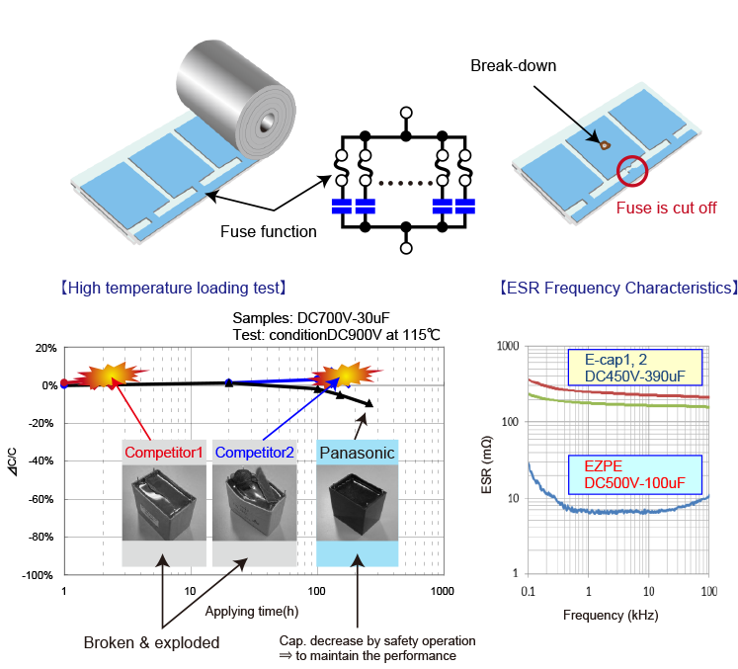

https://eu.industrial.panasonic.com/products/capacitors/film-capacitors/electronic-equipment-use
High Safety and Down-Sized Film Capacitor
ECWF(A), ECWF(D), ECWFE, ECQUA Series
